RESEARCH PAPER

History of Sexism in Advertising in 1950’s

ARTH 217
Professor J. Whelan
April 05, 2021
Jhatiana McMurrin

History of Sexism in Advertising in 1950’s

Introduction
Advertisements are considered influential forms of public media for consumers. During the 1950’s, sexist advertisements had an impact on the American family, whether promoting a household brand and/or car, women were stereotyped as inferior to men.

Throughout this paper, the history of sexism in advertising will be explained with a few examples of sexist ads from the 1950’s. Topics discussed will shed light on ads that promoted women in an appropriate manner. There will be an abstract explanation of an artist who had recreated 1950’s sexist ads. Following will be thoughts on the future of sexism advertising as the conclusion.

Sexist Advertisements
Before television and social media, companies used printed ads to promote their products. For a brand to maintain its cashflow it must attract consumers, which is why advertisements are used to appeal to the everyday family, man, woman, and child. During the 1950s, also known as the “advertiser's dream decade” and with the end of the war, Americans had a revived desire to spend their money. Advertisements in the 1950’s presented “real life” to American families. Companies use ads to rely on shortcuts to effectively depict specified ideas. Stereotypes are commonly used as shortcuts. The 1950s, which conjured up images of happy housewives and manicured green lawns, were the “norm” for women. Postwar propaganda, such as persuasive advertising campaigns, encouraged women to seek husbands, settle down, and have children.
The 1950s paved the way into the age of commercialism, with television and magazine advertising shaping American housewives' domestic views and igniting the wants and needs of the American people. Men were expected to be the head of the household and the sole provider in the 1950s, while women were expected to be the homemaker who cared for the children. Despite being encouraged to leave the workforce and start families, some women chose to pursue careers in clerical and retail jobs. There was a study that was conducted to examine the portrayal of women in Broadcasting Magazine during the 1950s. Framing analysis on a random sample of issues, it showed that most of the frames that women were seen through reflected stereotypical attitudes. In both cartoons and photographs, women were shown largely as decoration; when they were shown as something more than just scenery, it was likely to be in stereotypical roles as housewives, over-enthusiastic shoppers, or sex objects (Foust & Bradshaw, 2007, p. 94). All of which is ironic.
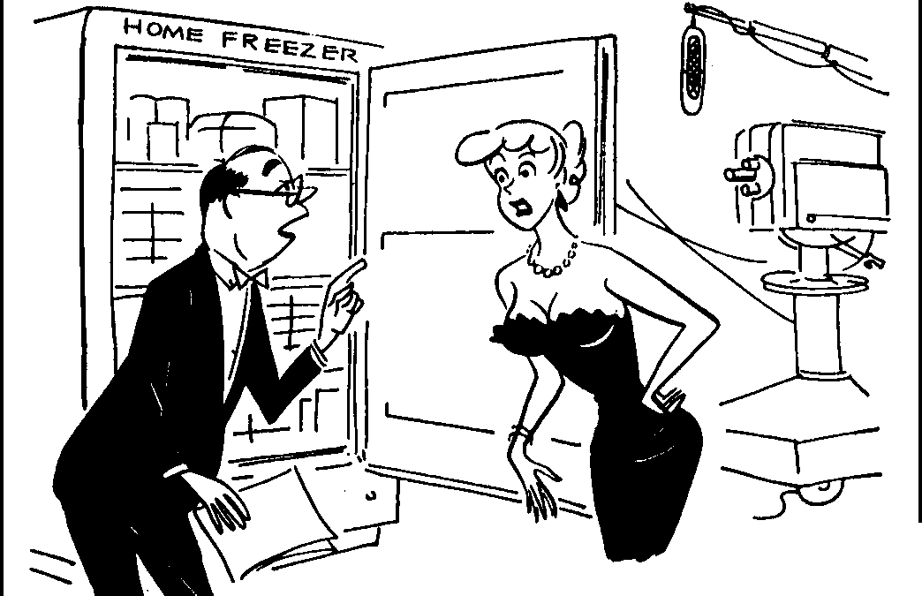
While men were off to war, majority of women took on manly duties and became the ‘man of the house”. It was not until World War II ended, men returned to the United States and back to work, women were now out of work and had turned toward home and domestic activities (Catalano, p. 45). The denigration of women was perpetuated by mass media advertising in women's magazines.

Drawn for BROADCASTING • TEl.ECASTJNG by Bid Hix
"... and when you say, 'note the big, over-sized chest,' be sure you point to the freezer.''

Figure 1. Broadcasting Magazine, February 27, 1956

Empowering Advertising
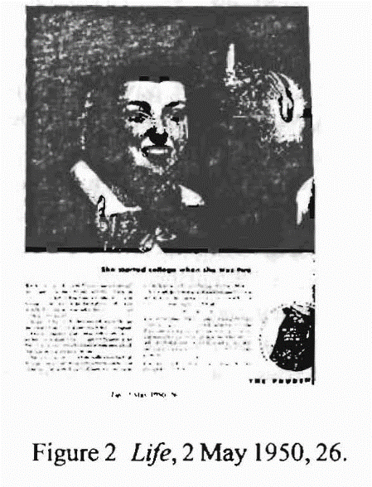
Feminism wasn’t popular until the 1960’s. In the 1950’s there were several feminists who declared this period as the highpoint of inequality. While there were many sexist advertisements printed, they were re-examined by feminists; Alice Courtney, Sarah Lockeretz, and Christina Catalano. According to 1950’s magazine ads, a woman's place was at home. While some advertisements depicted women in domestic settings, women were frequently depicted in other settings as well. Figure 2 contains an ad from Newsweek magazine in 1952. The woman pictured is using power tools to repair an airplane. (Note that the man in the ad is doing basic secretarial duties). Not only is this woman pictured outside of her supposed "place," but she is engaging in difficult mechanical labor in a job that is crucial to the safety and well-being of airplane passengers (Catalano, 2002, p. 52). Other positive ads included young women graduating from college (Figure 2), and women who traveled sometimes with her family or by herself.

Parallel Universe
What if gender roles were reversed and were promoted in advertisements? Would men like to be viewed as a “househusband”, cooking dinner, staying home, tending to his kids? In 2018, Eli Rezkallah, an artist, was inspired to create a series called “In a Parallel Universe,” which he recreates sexist ads from the Mad Men era by portraying men in traditional female roles. He reproduced eight vintage ad campaigns, and some were illustrations, in a carefully staged photograph that inverted the original genders (Stoughton). One ad stuck out amongst the eight ads that were recreated: The Chase & Sanborn Coffee ad. From a glance, the viewer can see a black and white photograph, where a man is sitting in a chair, he has a woman on his lap, and he has one arm raised up as if he were going to spank her (Figure 3). The advertisement was published in 1952, and the intended audience was housewives at the time. The advertisement is about a wife who would be punished if her husband discovers that she has purchased flat and state coffee. As a result, Chase & Sanborn made certain that their fresher coffee could be tested. This ad simply implemented the cause-and-effect strategy. With Rezkallah's reverse sexism perspective, are presented in a light that promotes women's empowerment.
Figure 3. Parallel Universe

Conclusion
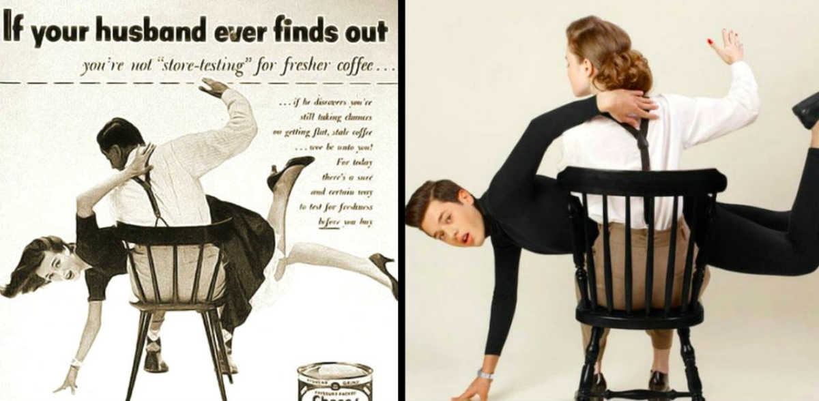
Advertisements are deemed as powerful forms of public media for consumers. During the 1950s, sexist advertising campaigns had quite an effect on the American family, whether they would be helping to promote a household product or an automobile. Women were stigmatized as inferior to men. Throughout the 1950s, men were expected to be the breadwinner and the sole provider, whereas women were expected to be the housewife who cared for the children. While some advertisements showed women in domestic settings, they were also frequently shown within other settings, such as graduating from college, living her own life by her own rules.

References

Cartoon, Broadcasting, Feb. 27, 1956, 134. Life, 2 May 1950, 26. Newsweek, 14 January l 952, 35.

Catalano, Christina. Shaping the American Woman: Feminism and Advertising in the 1950s. Vol. 3, no. 1, 2002, p. 6, https://digitalcommons.iwu.edu/cgi/viewcontent.cgi?referer=https://scholar.google.com/&httpsredir=1&article=1054&context=constructing

Foust, James C., and Katherine A. Bradshaw. "Something for the Boys: Framing Images of Women in Broadcasting Magazine in the 1950s." Journalism History 33.2 (2007): 93,95,97-100. ProQuest. 7 Apr. 2021.

Plakoyiannaki, E., Mathioudaki, K., Dimitratos, P. et al. Images of Women in Online Advertisements of Global Products: Does Sexism Exist?. J Bus Ethics 83, 101 (2008). https://doi.org/10.1007/s10551-007-9651-6

Stoughton, India. "Seven Photographs by Lebanese Artist Eli Rezkallah that Reveal how Sexist Advertising can be." The National, Feb 19, 2018. ProQuest, https://ecsu1891.idm.oclc.org/login?url=https://www-proquest-com.ecsu1891.idm.oclc.org/newspapers/seven-photographs-lebanese-artist-eli-rezkallah/docview/2003316258/se-2?accountid=10717.

